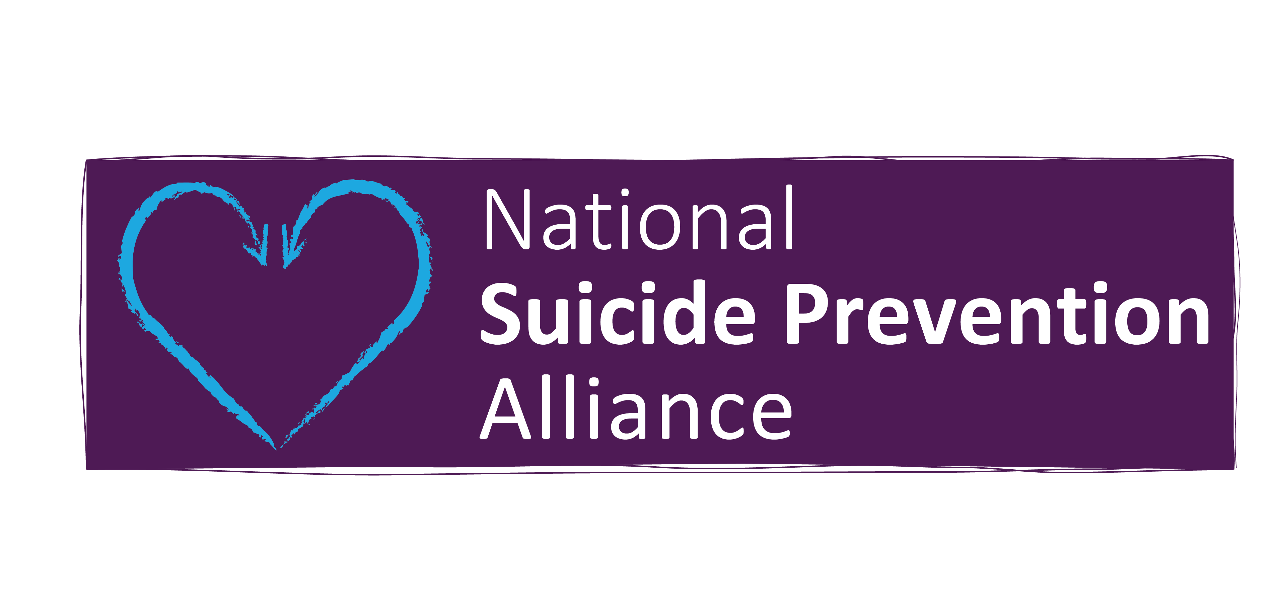

Diversity Monitoring Form

We undertake diversity monitoring to ensure we promote equality of opportunity for all who wish to work with us. It will help us ensure we work harder to encourage applications from under-represented groups.
This data will be separated from the application form.

Please tick the relevant boxes to each group or please self-describe as appropriate.

THIS FORM MAYBE AVAILABLE IN OTHER FORMATS AND SUPPORT CAN BE PROVIDED TO COMPLETE IN CONFIDENCE. Please ring 07483 027879 or email livedexperience@nspa.org.uk

1.Disability Do you have a disability? -You’re disabled under the Equality Act 2010 if you have a physical or mental impairment that has a ‘substantial’ and ‘long-term’ negative effect on your ability to do normal daily activities. You are also covered if you had a disability in the past.
Mental Health** | Blind or partially sighted | Deaf or partial loss of hearing
Learning Disability | Physical disability | Sensory disability (not already stated)
I self-describe as: | I do not have a disability | other please state: ………………………..
REASONABLE ADJUSTMENTS -please state what special requirements or reasonable adjustments you need as part of your involvement or at interview? No adjustments required
Please provide following adjustments:

**Mental Health Diagnosis- would you be willing to share this with us?
Yes, my diagnosis is:
NO I prefer not to I self-describe as:

2.Ethnicity
White |  |  |  |  | Black or Black British
British |  |  |  |  | African
Irish |  |  |  |  | Caribbean  Other please state………………  I self-describe as…………………
White Other |  |  |  |  | Asian or Asian British
Gypsy/Roma |  |  |  |  | Bangladeshi
Irish Traveller |  |  |  |  | East African Asian  Chinese  Sri-Lankan
Other please state:………  I self-describe as:………………… |  |  |  |  | Nepalese  Other please state:…………….  I self-describe as:…………………….
Mixed |  |  |  |  | Any other ethnic background  (please self-describe) ……………………..
White and Black African
White and Black Caribbean
White and Asian
Other (please specify): |  |  |  |  | Prefer not to say

3.Religion

Christian |  | Hindu |  |  |  | I self-describe  as:………………..
Jewish |  | Sikh  Zoroastrian |  |  |  | Prefer not to say
Muslim |  | Rastafarian
Buddhist |  | No Religion

4.Gender

Male Female I self-describe as………………….

5.Gender Re-assignment – is this different than at birth?

Yes
No

Prefer not to say

6.Sexual orientation – How would you describe your sexual orientation?

Heterosexual | Bisexual |  |  | Lesbian Woman |  |  | Gay Man
Prefer not to say | I self-describe as:………………………………….
7.Do you identify as Trans?
Yes No Prefer not to say I self-describe as:……………….
8.Pregnancy and maternity -which best describes your status?
Are you pregnant? |  |  |  | Have you had a baby in the last 12 months?
Yes | No |  |  | Yes |  |  | No
9.Marriage and Civil Partnership (please select relevant box)
Single | Married |  |  | Co-habiting |  |  | In a same sex civil partnership
Separated | Divorced |  |  | Widowed
10.Refugees and Asylum Seekers (if appropriate)
A Refugee |  |  | An Asylum Seeker
What country or region are you a refugee/asylum seeker from?

11.Language & Communications – would you need support if English is not your primary language or any other communication needs?

Interpreting and translation (please specify language)
Sign language (BSL)
Braille
Large Font
specific technology support (assisted technology)
other: please specify for any other or for any of the above

12.Age -which age range do you identify with?
16-24 | 25-34 | 35-44
45-54 | 55-64 | 65-74
75-84 | 85+ | Prefer not to say

13.Carer– are you a full-time carer?
Yes | No | Other (part-time)
prefer not to say | I self-describe as:

14.Education -Have you attended full-time education?
Yes | College | University
other please state: | No | Prefer not to say

15.Financial status -please note this question is to ensure we recruit people from all backgrounds regardless of income.
waged and in full time employment | Student | unemployed
Benefits recipient | Stay at home parent | other – please self-describe:

We appreciate you taking the time to complete this form, it will help us promote equal access and ensure wider and more diverse representation in our work

